Section 5. Cultural Information

The Koreans believe in Confucian values. (See Appendix D, Figure 1 for the Impact of Confucian Values upon South Korean Families). These values state that people should respect authority, respect the collective, behave virtuously, work hard, avoid extremes, and live moderately. There is also the concept of “face” in the Korean society. The South Koreans strives for harmony in their business and personal relationships. To prevent loss of face, Koreans will avoid confrontation or will tell others what they want to hear rather than tackling issues head on. It is important for HackerNest to demonstrates the Confucian values and the concept of “face” when conducting business in South Korea. For example, rather than saying “no” to an employee, say “try it”. Rephrasing the questions and answers in different ways will allow sides to maintain harmony in the relationship. During a meeting or negotiation with a local business, HackerNest should be very respectful and mindful of others’ “face” and dignity. (*Doing Business in South Korea*).

Korean is the official language in South Korea. The language itself has a number of dialects and the main dialect used in South Korea is the Hanguk dialect. English is used as a second language in South Korea. Though it is taught in schools, the majority of the population do not speak it freely. (*Study Country*). Therefore, to break down the language barrier and communicate freely with future sponsors, employees, and partners, HackerNest should hire someone who can speak both Korean and English fluently to help with the foreign expansion. Culture differences also impact communication. Because the South Koran favours harmony rather than confrontation, many Westerners often misunderstand silence as acceptance. To avoid communication problems, HackerNest should ask questions form several directions to verify that message has been successfully communicated. When making presentations and business plans, HackerNest should consider minimize words and maximize graphs, charts, and visuals to help communicate across languages and cultures.

It is important to spend time establishing a good business relationship and building trust with South Koreans. South Koreans may enquire about someone’s personal life, in an attempt to establish his or her age and status, and to build a relationship with that person. HackerNest should devote time getting to know its counterparts both professionally and personally; mix business with pleasure to develop, sustain and grow its network. When HackerNest is engaged in a conversation with its counterparts, HackerNest needs to answer each question honestly and openly, but without being boastful. If, by any chance, a trusted third party introduced HackerNest to a local business, it is more effective for HackerNest to establish a relationship with this domestic business. A slight bow followed by a handshake should never be forgotten when greeting someone in South Korea. In most cases, junior personnel will bow first to their senior colleagues. South Koreans prefer a softer handshake. A junior personnel should wait for the senior personnel to offer their hands first. And men should wait for women to initiate handshakes, as some women prefer to bow instead. During the handshake, both sides are allowed to support their right forearms with their left hands. Additionally, HackerNest is advised to make direct eye contact when addressing South Korean business professionals in order to show honesty and interest. HackerNest should acknowledge that South Koreans really care about body language. It is important to remember to keep legs straight and upper body in a slight stop to denote respect. A slight bow is used when expressing an apology, and a deep bow is used when saying goodbye. Sneezing and blowing nose in public is considered as a rude behavior. To be polite to others, representatives from HackerNest should use both hands when giving or receiving anything such as business cards and gifts. Both the employers and the employees of HackerNest should dress appropriately for their work surroundings. Black, blue and brown-colored suits are recommended. While tight skirts, low necklines, shorts, and sleeveless tops should be avoided. (*Doing Business in South Korea*).

HackerNest needs to book meetings well in advance and make sure to arrive punctually. HackerNest should approach the other party formally and friendly, but avoid making jokes as this could be interpreted as a lack of respect. The top-down management structure in South Korean businesses reveals the importance of being respect to authority. The most senior person from HackerNest should enter the room first and greet the most senior representative of the other party. Representatives of HackerNest should introduce older people to younger people and women to men. When addressing someone’s name, representative should use their professional (such as professor, doctor, engineering) and honorific titles. Korean names are written with family name and then given name. The most common address in Korean is family name followed by title, for example “Professor Lee”. HackerNest’s representative should be prepared to ask personal questions when they first meet a South Korean. This is because Korean businesses valued hierarchy and the counterpart is trying to determine where the representative fit in the hierarchy. HackerNest should also prepare a good supply of business cards as it is customary to exchange business cards when meeting a business person for the first time. (See Appendix D, Figure 2 for Korean Business Card). The business cards should be translated into Korean on one side, and when exchanging business cards, always remember to give out and receive it with both hands. Business cards represent “face”. Be sure to examine someone’s business card before putting it away, and never write on someone’s card in their presence unless they are happy for you to do so. HackerNest should only expect to get to know the partner during the initial meetings. There is always tea or some type of drink offered during the meeting. It is impolite to refuse so better to accept even if not consumed. Business discussions should not be started until these rituals have been completed. In a following up meeting or a business negotiation, always allow the counterpart plenty of time to express their opining and avoid dominating the conversation. Be patient, but firm, allow plenty of time for negotiations and remain dignified throughout. (*Doing Business in South Korea*).

The culture of gift giving persists in South Korea. Giving small gifts is part of the process of building a business relationship in South Korea. HackerNest should bring items from its home country, such as icewine, as gifts from a business’s particular region will be especially well-received. The gift should be branded with HackerNest’s logo and wrapped. Give and receive a gift with both hands. It is customary for South Koreans to refuse the gift once or twice as a gesture of humility. Hospitality is also a part of South Korean business culture. HackerNest’s representatives might be invited to dinner in a restaurant or in someone’s home. Before dining, younger representatives should wait for older people to pick up their tableware first. When dining, representatives should know that it’s not appropriate to hold rice or soup bowl in hand during the meal. Spoons and chopsticks should not be rested on any bowl or dish or be held together in one hand. When an elderly person gets up, the younger people should also get up. Alcohol might be offered during dining. Often, key commercial information is revealed at the very end of a drinking session so HackerNest needs to be alert enough to catch the message. Avoid emptying glass if the drink is enough. If someone doesn’t want to drink, excuse himself or herself with medical or religious reasons. Lastly, it is polite to fill other people’s glasses first. (*Doing Business in South Korea*).

The South Koreans follow the Gregorian calendar. However, a few holidays are based on the lunar calendar. The Koreans celebrate both Korean and western holidays, such as Korean New Year, Harvest Festival, and Christmas. (See Appendix D, Figure 3 for List of Holidays in South Korea). During the official holidays, offices and banks are closed but public places such as museums, most restaurants, and department stores are open. (*Public Holidays*). HackerNest should avoid arranging business meeting or negotiation, or hosting tech meetups or hackathons during holidays. Chuseok, or the Harvest Festival, is one of the biggest and most important holidays in Korea. During the festival, family members gather together to share food and stories and give thanks to their ancestor. (*Traditional Korean Holiday, Chuseok*). HackerNest should provide their employees with enough time off so they can visit their hometowns to spend time with their family and friends. (See Appendix D, Figure 4 for Photo of Chuseok Custom).

A Korean meal is centered around rice and soup and likely a meat dish, invariably served with a vast assortment of side dishes known as banchan. Kimchi is ubiquitous in every meal. HackerNest should provide kimchi for its employee at every meal. Doenjang, which is similar to Japanese miso, and gochujang, a spicy chilli paste, are found in every dish as well. (See Appendix D, Figure 5 for Traditional Korean Meal). (*Food and Drink in South Korea*). HackerNest will be providing food for hackathon volunteers and participants. Since most Koreans love spicy food, spicy Korean food and kimchi must be provided. Rice, Doenjang, gochujang, and an addition of 2 side dishes and one meat dish should also be offered. Since Korean cuisine can be heavy in salt, water and drinks should be accompanied with the meal. (See Appendix D, Figure 6 for Potential Meal for Hackathon).

Since their settlement in prehistoric times, the Koreans have developed a unique tradition related to the way they dress. The Koreans learned to use various fabrics, such as hemp, ramie, cotton, and silk to make a range of clothing that not only attractive but also provided them with effective protection during winter and summer. The traditional Korean clothes are called hanbok. (See Appendix D, Figure 7 for Traditional Korean Clothes). Those clothes are only worn on festivals or special anniversaries nowadays. In recent years, Korea has become the home to many fashion designers who combine traditional Korean designs and patterns with a modern artistic sensibility. The Koreans today seem to prefer clothes inspired by modern Western styles to their traditional clothes. (*Clothing and Fashion*). HackerNest should establish a dress code for its employees. This dress code should restrict the employees to wear business attired on weekdays. It is a tradition to hand out souvenir shirts to participants and volunteers at each hackathon. Instead of designing new, colorful shirts with traditional elements, HackerNest can reuse the shirt design from past Canadian hackathons.

To wrap up, because the South Korean culture is extremely different from the Canadian culture, HackerNest must study the Korean cultural norms in depth to gain insight into the Korean citizens, customers, and businesses.

Appendix D.

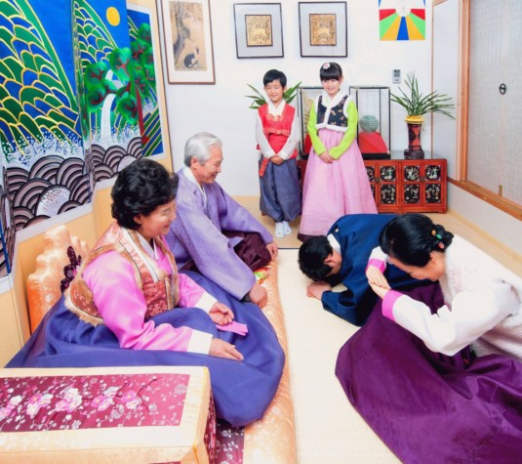

Figure 1.

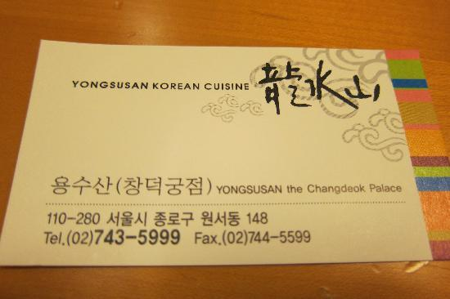

Figure 2.

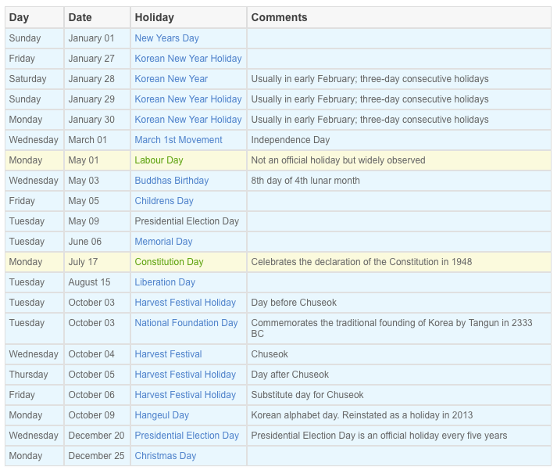

Figure 3.

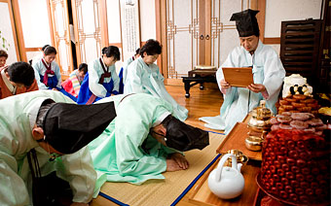

Figure 4.

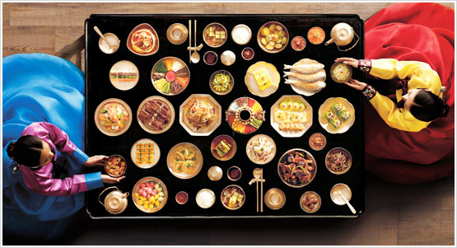

Figure 5.

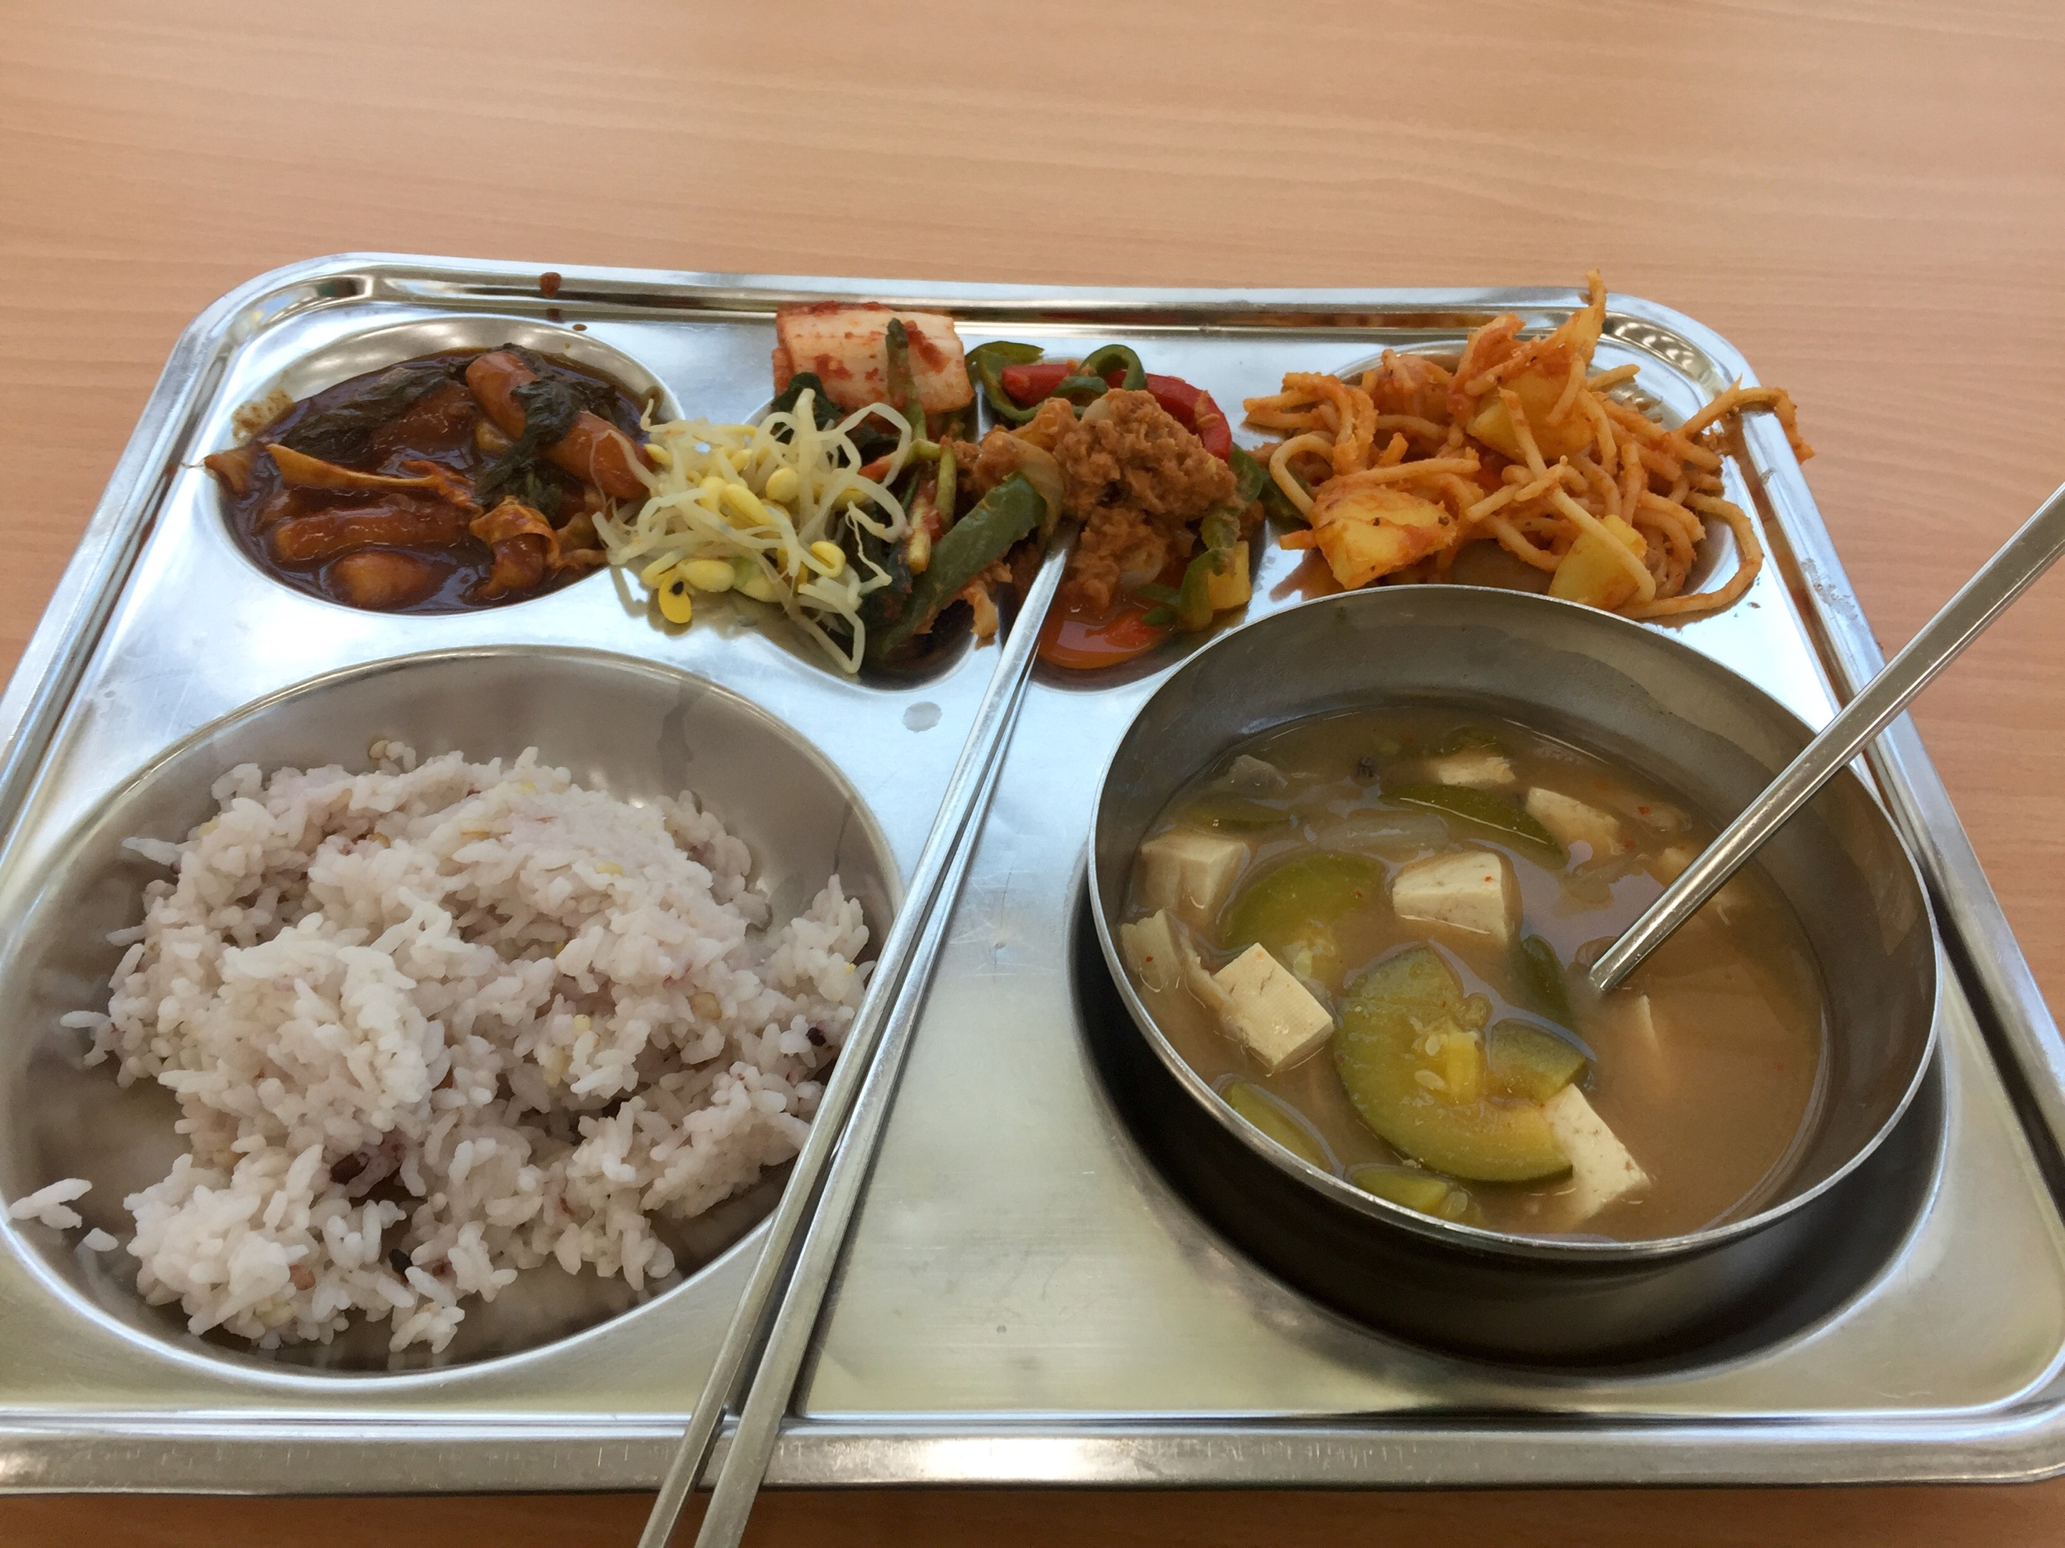

Figure 6.

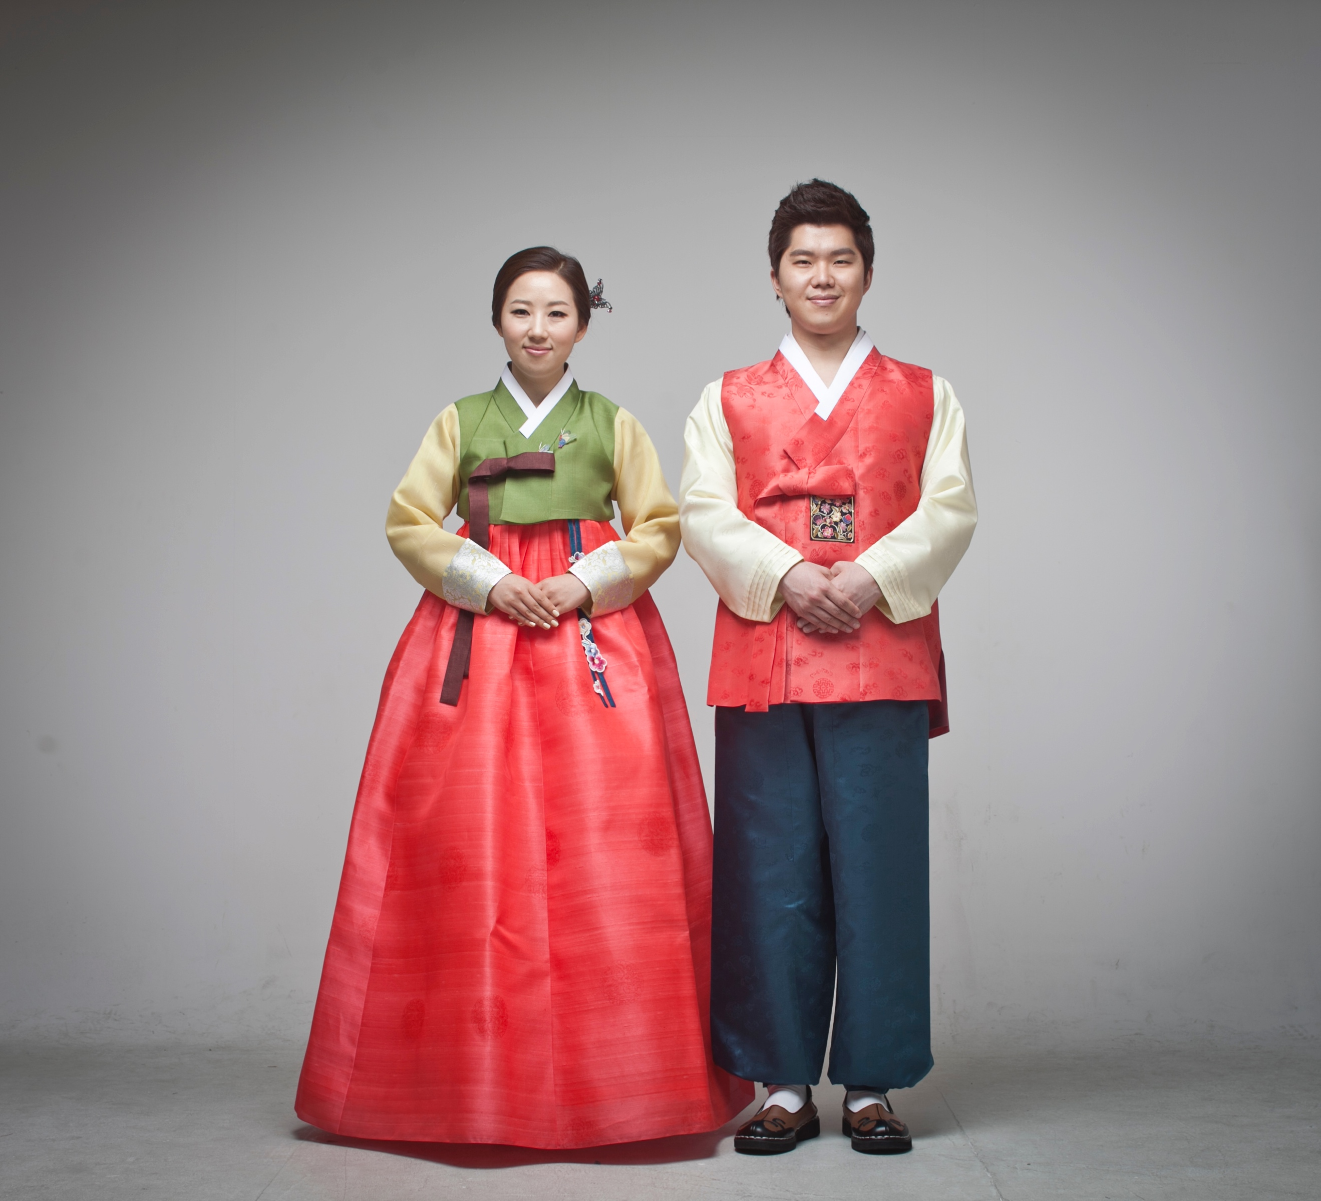

Figure 7.

<http://www.southkorea.doingbusinessguide.co.uk/the-guide/south-korean-culture/>

<http://www.officeholidays.com/countries/south_korea/>

<http://english.visitkorea.or.kr/enu/ATR/SI_EN_3_6.jsp?cid=811650>

<https://english.visitkorea.or.kr/enu/TRV/TV_ENG_1_1.jsp>

<https://www.gapyear.com/countries/south-korea/food-and-drink>

http://www.korea.net/AboutKorea/Korean-Life/Clothing

<https://english.visitkorea.or.kr/enu/AKR/AK_ENG_2_2.jsp>